# DAD 220 Cardinality and Targeted Data

Replace the bracketed text in this template with your screenshots and responses. Then submit it to the Module Four Lab for submission, grading, and feedback. Screenshots should be sized to approximately one quarter of a page. Written responses should be in complete sentences. Rename this document by adding your last name to the file name before you submit.

1. **Retrieve employee tuples and identify the number of employees** in San Francisco and New York.

select firstName, lastName, jobTitle, offices.city from employees inner join offices on employees.officeCode = offices.officeCode where state = 'NY';

1. **Retrieve order details** for orderNumber 10330, 10338, and 10194 and **identify** what **type of cardinality** this represents in the entity relationship model.

This type of cardinality represented in the entity relationship model is one to many. One order can have many different details as shown listed below as well in the ERD. The command used,

SELECT orders.orderNumber, orderDate, productName, quantityOrdered, priceEach, quantityOrdered*priceEach AS TOTAL_PRICE

FROM orders INNER JOIN orderdetails ON orders.orderNumber = orderdetails.orderNUmber

INNER JOIN products ON orderdetails.productCode = products.productCode

WHERE orders.orderNumber IN ( 10330, 10338, 10194) ORDER BY orders.orderNUmber, productName;

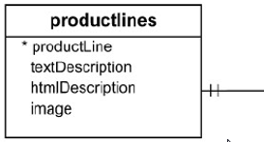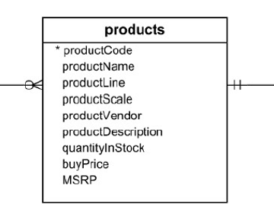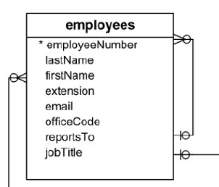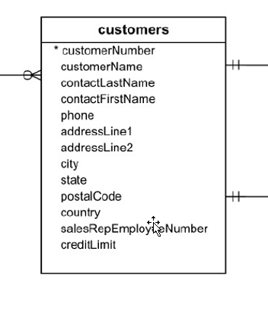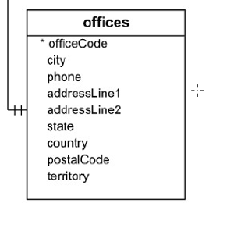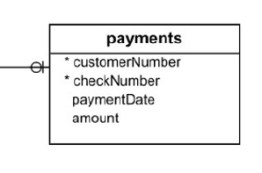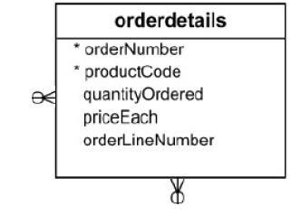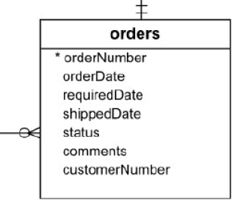

1. **Delete records** from the payments table where the customer number equals 103.
   1. describe payments;

SELECT *FROM payments WHERE customerNumber = 103;

DELETE FROM payments WHERE customerNumber = 103;

b. SELECT * FROM payments WHERE customerNumber = 103;

1. **Retrieve customer records** for sales representative Barry Jones and **identify** if the **relationships** are one-to-one or one-to-many**.**
   1. Barry Jones relationship is one- to – many because he is one sales rep with many customers.

SELECT CONCAT(employees.firstName, " ", employees.lastName) AS SALES_REP,customers.customerName AS CUSTOMER FROM employees INNER JOIN customers ON employees.employeeNumber = customers.salesRepEmployeeNumber WHERE employees.employeeNumber = 1504;

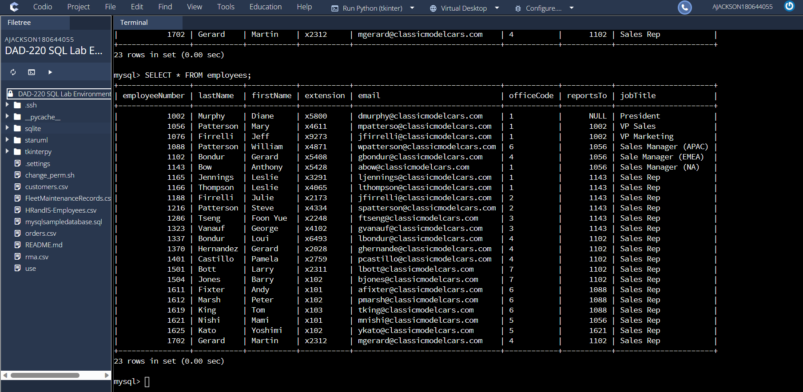

1. **Retrieve records** for customers who reside in Massachusetts and **identify** **their sales rep and the relationship of entities**. Identify if these entities demonstrate one-to-one or many-to-many relationships.
   1. SELECT * FROM customers WHERE customers.state ='MA';

SELECT CONCAT(employees.firstName, " ", employees.lastName) AS SALES_REP,customers.customerName AS CUSTOMER FROM employees INNER JOIN customers ON employees.employeeNumber = customers.salesRepEmployeeNumber WHERE customers.state= 'MA';

The relationship of entity is one to many as Julie and Steve both are one sales rep with many customers in the state of MA.

1. **Add one customer record** with your last name using an INSERT statement. You may use the name of a celebrity or fictional character if you don’t use your own name.

INSERT into customers value ( 497, 'Drea Unique Dreams', 'Jackson','Andrea', '859-638-3032', '10 Woodsong Ct','NULL', 'Amelia', 'OH', '45102', 'USA', '1401','1000.00');

1. **Reflection**
   1. **Define how cardinality is applied** to the databases you’ve been working with and why different numbers of records returned from the different offices.
      1. In the databases, cardinality refers to the data in a column of a table and the unique values in it. An example of this would be the one-to-many relationship that is present for the salesmen in relation to the customer from questions four and five. Each salesperson has multiple customers so the one is in relation to many customers. Which means that although a salesperson may have many customers there are assigned to just one salesperson.
      2. The reason why different numbers of records are returned from the different offices is that each office has its own set of data. An example of this is found in question one where CA returned 6 rows of data in comparison to NY three. This is due to CA seems to be the corporate office where not just salespersons are employed but also heads of the company.
   2. **Compare and contrast** the different **queries** you ran and how cardinality applies to them.
      1. In the queries that I ran cardinality applies in the relationship between the salesperson and the state the business they are assigned to is trackable as well as the amount of business that company brings in. When allowing the one-to- many rule to be applied one salesperson is over multiple companies and each company buys x number of items. Through the queries we can see the total business brought in by each company and the salesperson overseeing that profit. In addition to pattern of behavior on what products are being bought and the cost to the business itself as well as the customer.
   3. **Describe two** of the crucial **benefits** **of cardinality** in this type of database.
      1. Cardinality is the connection between database rows and tables to another. It links together information that allows for the structure of a database to be simplified as well as access easier. Another benefit is that it allows users to see who does what, what salesperson are associated with what business which allows for easy tracking of complex data.